# **Project Report:** Visualizing Data Using Tableau

## **Introduction**

The objective of this report is to provide a comprehensive analysis of the sales data from the AdventureWorks dataset, with a focus on uncovering valuable insights that can drive business decisions and strategies. AdventureWorks is a leading company in the sales industry, and understanding the patterns and trends in their sales data is crucial for maintaining and improving their market position.

I will follow the six phases of the Structured Approach to Data Analytics to ensure a systematic and thorough examination of the data. These phases include Ask, Prepare, Process, Analyze, Share, and Act. Each phase builds upon the previous one, leading to actionable insights that can significantly benefit the business.

In the "**Ask**" phase, I will define the key questions that will guide my analysis. These questions are designed to address critical aspects of the sales data, including monthly sales trends, online versus non-online sales, delivery performance, salesperson performance, geographic sales comparisons, top sales reasons, and potential correlations with external factors.

## **1. Ask**

In this phase, I will outline the specific questions that my analysis aims to answer. These questions are formulated to provide rich insights into the sales data and to address the business needs effectively. The questions are as follows:

### What is the overall monthly sales trend (rise and falls) over the specified period, and is there seasonality?

* + This question aims to identify the general trends in sales over time, highlighting any seasonal patterns that could influence business strategies.

### How do the sales trends compare between online and non-online orders over time?

* + By comparing the sales trends of online and non-online orders, I can understand the different dynamics and growth patterns in these two sales channels.

### How does delivery performance vary across different regions or sales territories?

* + Evaluating delivery performance by region or sales territory helps in identifying areas that might need improvement and ensuring customer satisfaction across all regions.

### How do sales compare across different regions?

* + Comparing sales across different regions allows for a better understanding of market performance and potential opportunities for growth in various geographic areas.

### What is the Year over Year Growth for each product category?

* + Year-over-year growth analysis for product categories offers insights into product performance and can guide decisions on product development and marketing strategies.

### How does the day of the week an order was placed affect sales both online and offline?

* + Investigating correlations with day of the week an order was placed can reveal additional insights and help in aligning production and sales strategies with consumer demands.

These questions will guide the subsequent phases of my analysis, ensuring that I gather and process the relevant data to uncover actionable insights for AdventureWorks. The findings from this analysis will provide a solid foundation for making informed business decisions and optimizing sales strategies.

## **2. Prepare**

In this phase, I examined the provided datasets to understand their structure and identify any issues that need to be addressed in the Process phase. The data for this project includes four different tables: AdventureWorks.SalesOrderHeader, AdventureWorks.SalesReason, AdventureWorks.Employee, and AdventureWorks.SalesTerritory.

Here is a summary of the datasets:

* **AdventureWorks.SalesOrderHeader:** This table contains 31,465 rows and 15 columns.
* **AdventureWorks.SalesReason:** This table contains 10 rows and 4 columns.
* **AdventureWorks.Employee:** This table contains 290 rows and 6 columns.
* **AdventureWorks.SalesTerritory:** This table contains 10 rows and 4 columns.

I also went ahead to write SQL queries to get two other tables from the AdventureWorks database.

* **AdventureWorks.Products_Extracted:** This table has 121,317 rows and 5 columns (SalesOrderID, OrderQty, ProductID, SubcategoryName, CategoryName)
* **AdventureWorks.Customers_Extracted:** This table has 19,185 rows and 3 columns (CustomerID, TerritoryID, CustomerType)

During this phase, I focused on identifying the structure and relationships between these datasets to ensure they would support the analysis objectives. I also made note of any potential data quality issues, such as missing values or inconsistencies, which would be addressed in the "Process" phase.

## **3. Process**

In the Process phase, I focused on transforming the data to enable meaningful analysis and visualization. Although the data provided was relatively clean, it was essential to create the necessary parameters and calculated fields to align with the specific goals of my analysis. This phase involved setting up the groundwork for dynamic and insightful visualizations.:

1. **Creation of Parameters**
   1. Select Year Parameter: This parameter was created to allow users to dynamically select the year they want to analyze within the dashboard. By enabling year selection, users can focus on specific time periods and observe trends or patterns relevant to that year. This enhances the interactivity and usability of the dashboard.
2. **Development of Calculated Fields**

I developed several calculated fields to meet the analysis objectives and facilitate the creation of meaningful visualizations:

1. **Region from Country Code Column:**This calculated field was created to derive the region based on the country code present in the data. By categorizing data by region, I was able to analyze and compare sales performance across different geographical areas, which is crucial for understanding regional trends.
2. **Current Year (TotalDue) from TotalDue and Order Date Columns:**This field calculates the total sales (TotalDue) for the current year, based on the selected year from the Select Year parameter. It is used to track the overall sales performance for the year of interest.
3. **Previous Year (TotalDue) from TotalDue and Order Date Columns:** Similar to the Current Year (TotalDue) field, this calculated field computes the total sales for the previous year. It allows for a comparison between the current year and the previous year, which is essential for understanding year-over-year growth and trends.
4. **Ship Date Difference from Order Date and Ship Date Columns:** This field calculates the difference between the order date and the ship date, providing insights into delivery performance. By analyzing the shipping time, I could assess how efficiently orders were fulfilled and identify any potential issues in the delivery process.
5. **Sales Type from Online Order Flag Column:** This calculated field categorizes sales as either "Online" or "Offline" based on the Online Order Flag column. It is critical for comparing the sales performance of online versus offline channels and understanding how each contributes to overall sales.
6. **% YoY Growth (TotalDue) from Previous Year (TotalDue) and Current Year (TotalDue) Columns:** This field calculates the year-over-year growth percentage for total sales. It provides a key performance indicator (KPI) that shows whether sales are growing or declining compared to the previous year, offering insights into the business's performance over time.

Through these calculated fields and parameters, I was able to tailor the data to the specific needs of the analysis. This preparation allowed for the creation of dynamic, user-friendly, and insightful visualizations that effectively address the business questions outlined in the "Ask" phase. The resulting dashboard is not only interactive but also provides actionable insights that can guide business decisions.

## **4. Analyze**

In the Analyze phase, I performed the analysis to answer the questions and gain meaningful insights that drive business decisions. Here’s a detailed breakdown of my analysis for each question:

1. **Monthly Sales Trend (Rise and Falls) Over Time:** To examine the monthly sales trend over time, I started by creating a KPI with a ban that contains sparklines comparing the previous year to the currently selected year. I created a calculated field to calculate the YoY Growth percentage as well and the sum of TotalDue for the current year. This allowed me to properly visualize sales by month for each year.

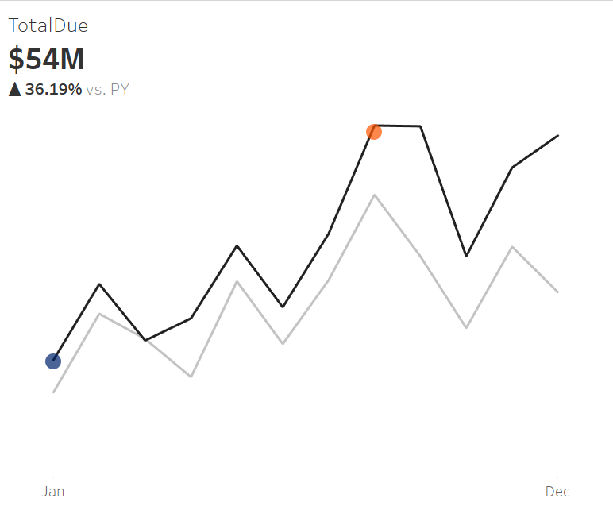

1. **Sales Trends Comparison Between Online and Non-Online Orders:** Next, to compare sales trends between online and non-online orders, I created a calculated column called 'Sales Types' using the values from the 'OnlineOrderFlag' column, where 1 represents online orders and 0 represents offline orders. I then made a line plot comparing both sales types over time..

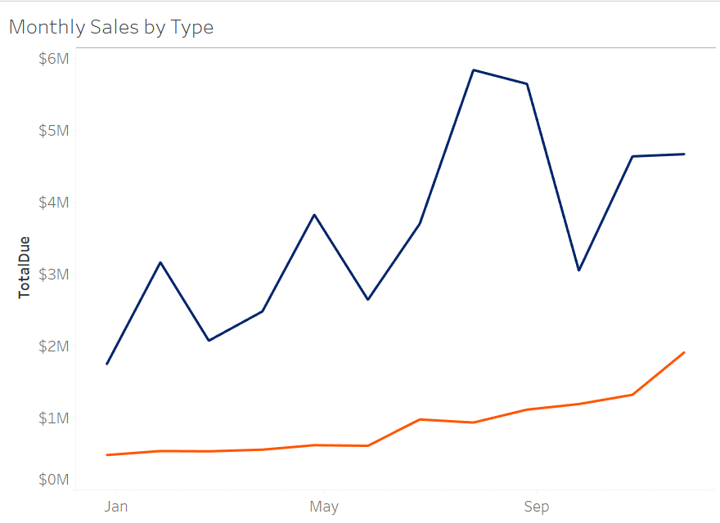

1. **Delivery Performance Across Different Sales Countries:** To analyze how delivery performance varies across different sales regions, I calculated the number of days between the 'OrderDate' and 'ShipDate' by creating a new column called 'Ship Date Difference' using the DATEDIFF function. I then created a bar plot to visualize it.

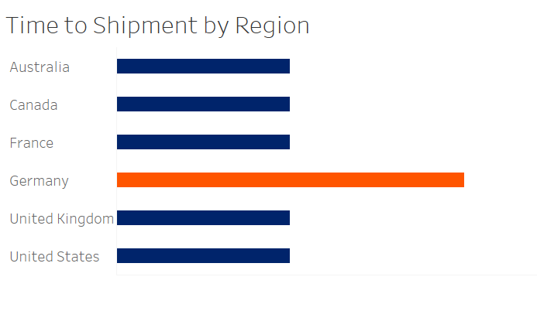

1. **Sales Comparison Across Different Countries:** To compare sales across the different countries, I visualized the data on a map..

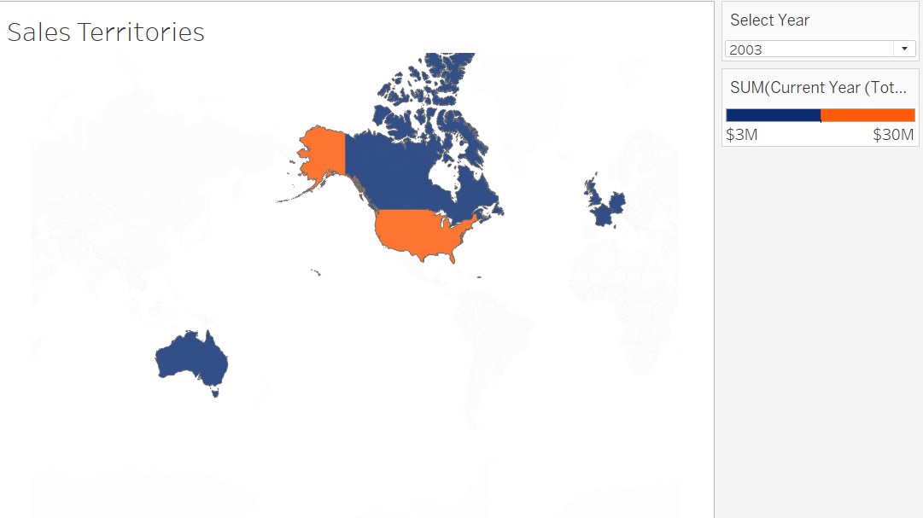

1. **Effect of Day of the Week on Sales (Online vs. Offline):** Finally, to understand how the day of the week an order was placed affects sales for both online and offline channels,

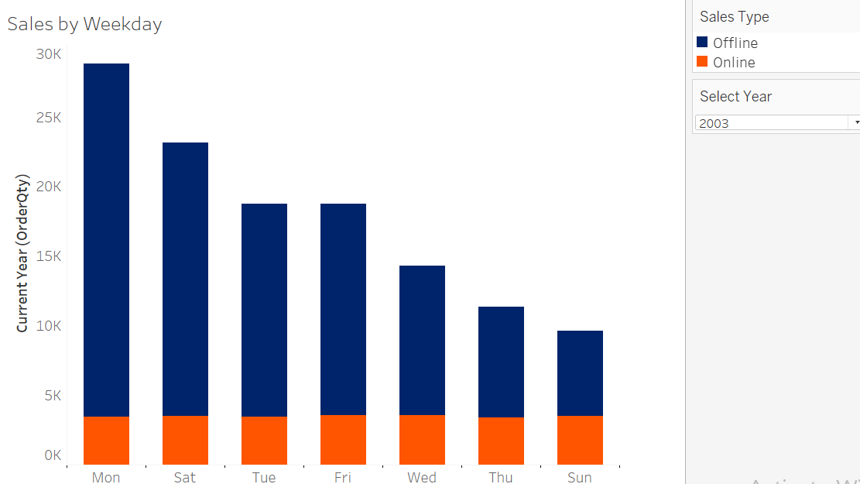

By conducting these analyses, I prepared the data to generate insights that can drive business decisions and strategies. The results from these analyses will be shared in the next phase.

## **5. Share**

In the Share phase, I present the insights derived from the analysis, providing valuable information that can inform business decisions and strategies. Here are the key insights gained from each analysis:

### Overall Monthly Sales Trend

* + The analysis revealed a general upward trend in sales over time, indicating an increase in sales from 2001 to 2004, followed by a decline starting in July 2004. This pattern suggests that the company experienced growth initially, but sales began to drop in the latter part of the analyzed period.
  + There was a noticeable seasonality in sales, with repeating patterns observed in certain months each year. Specifically, top sales were recorded in February, May, August, and November. This seasonal trend suggests that certain times of the year are more favorable for sales, possibly due to market conditions, holidays, or promotional activities. Further diagnostic analysis can be conducted to identify the factors influencing high sales in these months.

### Sales Trends Comparison Between Online and Non-Online Orders

* + The comparison between online and offline sales trends showed that more orders were placed using the online sales channel, but the revenue generated from offline sales was significantly higher. Specifically, 88% of total orders were placed online, contributing only 23% of total sales revenue, while 12% of orders placed offline accounted for 77% of total revenue.
  + This finding indicates that while online orders are more frequent, they tend to generate lower revenue per order compared to offline orders. This suggests that the company might need to explore strategies to increase the average order value for online sales or leverage the higher revenue potential of offline sales.

### Delivery Performance Across Different Sales Countries

* + The analysis of delivery performance showed that orders were generally shipped within 7 days across all countries, except for Germany, where shipping could take up to 8 days sometimes. This indicates that the company's logistics operations are fairly consistent, but there may be specific challenges or inefficiencies in the German market that need to be addressed to improve delivery performance.

### Sales Comparison Across Different Countries

* + The sales comparison across countries showed that the United States generated the highest sales ( $82,425,341.28) which can be attributed to the fact that there are five territories in the United States (Northwest, Northeast, Central, Southwest, Southeast). The United States was followed by Canada ($21,501,812.46) and Australia ($12,197,515.53). Germany generated the least total sales ($5,939,763.50) among the countries analyzed.
  + These insights highlight the country with the strongest sales performance and can guide the company in allocating resources and efforts to maximize growth in high-performing areas while developing strategies to boost sales in underperforming countries like Germany.

### Effect of Day of the Week on Sales (Online vs. Offline)

* + The analysis showed that while the majority (87.9%) of orders were placed online, Sundays saw the highest order placements for both online and offline sales. This insight can help the business plan and allocate resources, such as staff and server capacity, to meet the higher demand expected on Sundays.
  + Understanding the weekly sales pattern can help in optimizing operations and ensuring that the company is well-prepared to handle peak order times effectively.

By sharing these insights, the company can make informed decisions and develop strategies to enhance sales performance, improve delivery efficiency, recognize and reward top salespersons, and optimize marketing efforts. These insights provide a solid foundation for driving business growth and achieving strategic objectives.

## **6. Act**

Based on the analysis and insights obtained, several actionable recommendations can help AdventureWorks improve its business performance:

### 1. Address the Decline in Sales Post-2004

Investigate the factors contributing to the decline in sales starting in July 2004. This could involve reviewing market conditions, competition, internal changes, or external events that may have impacted sales. Implement strategies to counteract these negative influences and regain the growth trajectory.

### 2. Leverage Seasonality for Strategic Planning

Utilize the insights on seasonality to plan marketing campaigns, promotions, and inventory management. Since February, May, August, and November are peak sales months, the company should align its promotional efforts and stock levels to capitalize on these periods. Additionally, identifying the factors behind these seasonal spikes can help replicate the success in other months.

### 3. Enhance Online Sales Revenue

Although online orders are more frequent, they generate less revenue compared to offline orders. To address this, the company should explore strategies to increase the average order value for online sales. This could include offering bundled products, upselling and cross-selling, implementing loyalty programs, and improving the online shopping experience.

### 4. Improve Delivery Performance in Germany

The slightly longer delivery times in Germany suggest potential inefficiencies in the logistics process for that country. Conduct a detailed analysis to identify the root causes and implement measures to streamline operations. This could involve optimizing shipping routes, partnering with local couriers, or enhancing warehouse efficiency in Germany.

### 6. Focus on High-Performing Countries

With the United States, Canada, and Australia showing strong sales performance, allocate more resources to these countries to further boost sales. This could include targeted marketing campaigns, increased sales personnel, and tailored promotions. Simultaneously, develop strategies to improve sales in underperforming regions like Germany.

### 8. Resource Allocation Based on Weekly Sales Patterns

The finding that Sundays have the highest order placements for both online and offline sales can guide resource allocation. Ensure that adequate staff, server capacity, and inventory are available to handle the increased demand on Sundays. This proactive approach can enhance customer satisfaction and operational efficiency.

By implementing these recommendations, AdventureWorks can address identified issues, capitalize on opportunities, and enhance overall business performance. These actions, informed by data-driven insights, will help the company achieve its strategic objectives and drive sustained growth.

[Click Here](https://public.tableau.com/views/M2S1_Project_17253566745090/Dashboard1?:language=en-US&publish=yes&:sid=&:redirect=auth&:display_count=n&:origin=viz_share_link) to view my dashboard